

**Dr.Cook – Interactive Recipe Website**

Lidor Kupershmid – 318187416

Aviv Aytek – 206713604

Lidor Anfinger – 206953895

Dror Hershkovitz – 206891459

**Direct link to the website**[**:**](:%20%20https:/doctor-cook.up.railway.app/recipes)  [**https://doctor-cook.up.railway.app/recipes**](https://doctor-cook.up.railway.app/recipes)

**Introduction**

Welcome to the Dr. Cook User Manual! This guide will help you navigate and make the most of your experience on Dr. Cook, your go-to online destination for discovering, and cooking delicious recipes. Whether you're a home cook looking for inspiration or a seasoned chef eager to contribute, this manual will provide step-by-step instructions to ensure you have the best experience possible.

**General** **Overview**

* **Home Page**: The starting point of your culinary journey, featuring easy navigation to browse and explore recipes.
* **About Page**: Learn about the mission, vision, and goals behind **Dr. Cook** and the people who created it.
* **Recipes Page**: A comprehensive collection of recipes categorized by difficulty, cuisine type, and ingredients.
* **Recipe Detail Page**: View step-by-step instructions, ingredient lists, and cooking tips for each recipe.
* **Favorites**: Have any favorite meals? Kindly add the by pressing the Heart sign.
* **Interactive Cooking Assistant**: A smart guide that helps you cook with real-time instructions and voice commands.

**Getting Started**

* Visit **Dr. Cook** to access the main page: [Dr. Cook Website](https://doctor-cook.up.railway.app/recipes)
* Quickly browse featured recipes or navigate to different sections such as **All** **Recipes**, **Favorites** and **About us**.
* Use the navigation bar to explore the website efficiently.
* Switch between **light mode** and **dark mode** for your preferred viewing experience.
* Use the search bar with to Sort & Filter by category or name as quicker as possible!

**Home page (Computer + Phone View)**

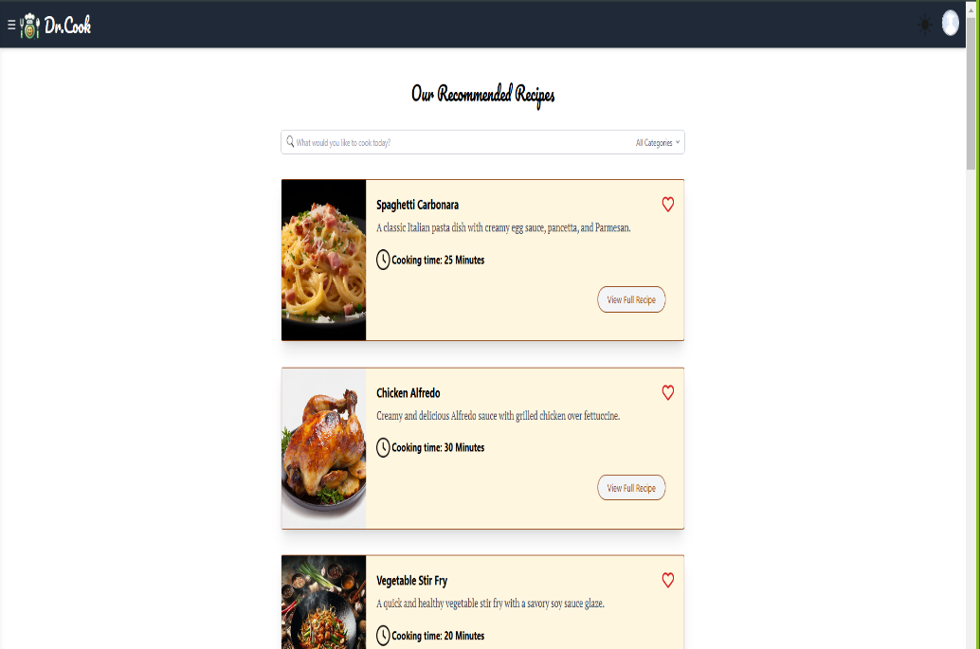



This is the main page you meet when you navigate to our website.  
Make sure you press on the “Student” icon to login in order to reach full functionality in our website!

**Login Page (Computer and Phone View)**

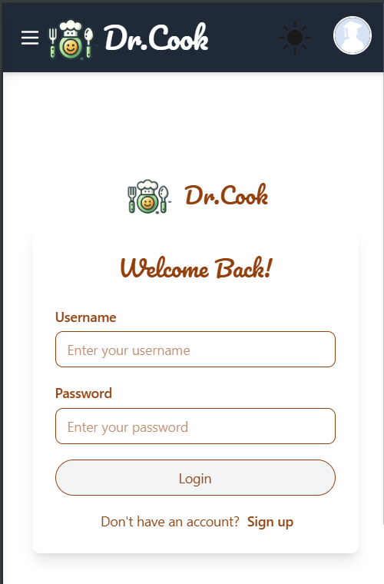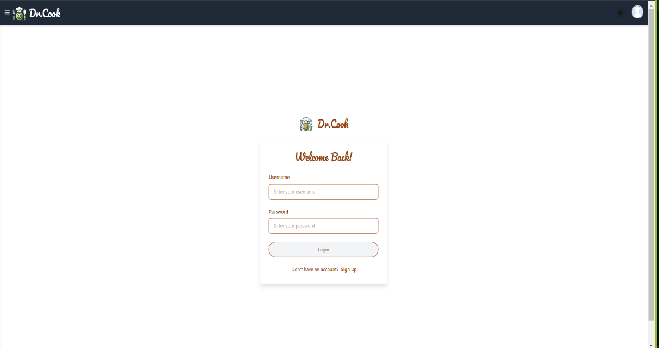



Please enter your login details, **If its you first time,** kindly use the “**Sign Up”** button to sign up.

After you sign up and login, youll be able to add any meals to favorites.

Youll Icon change to a giraffe – meaning you’re a sign in user.

**Sign Up Page (Computer and Phone View)**

Kindly fill the needed fields for you to login, which are name, username and password.

Please don’t use your credentials.

**Top Bar (Computer and Phone View)**

At the top bar youll find a “hamburger bar” at the left corner, which will immediate open a tab with few sections.

The next icon is the dark/light mode icon for you comfortability.

The giraffe Icon means that your logged in, if a “Student” icon appears, that means that you’e not logged in, make sure to follow the right steps to login and signup if needed.

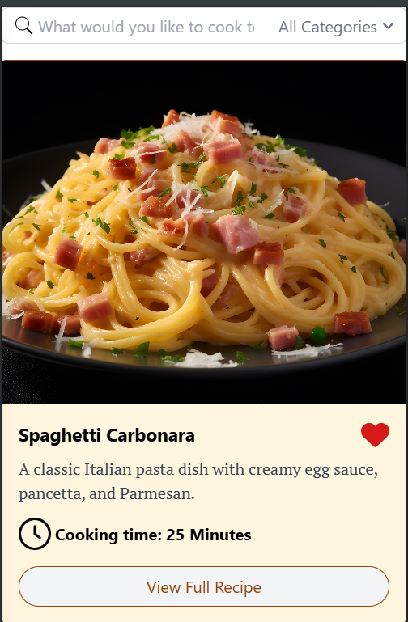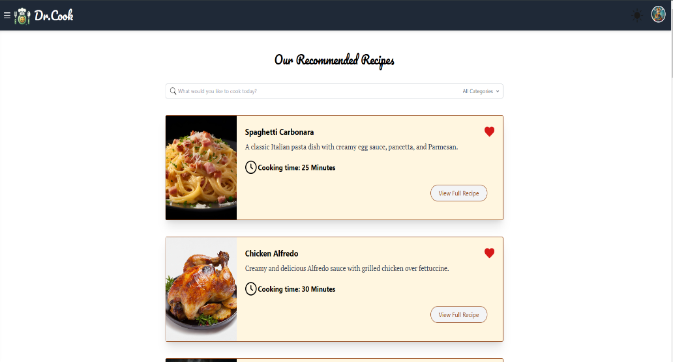**Home Page features (Computer and Phone View)**



Youll have few options when you navigate  
In our home page.



The “Search” Icon at the top will help you navigate

Through categories, you can also click the “All Categories” Button to sort meals efficiently.

The “Heart” Logo will immediately add the meal you liked to the you favorite meals, which will appear in the “Favorites” Section.

“View Full Recipe” Button will navigate you to inner recipe view which will show detailed instructions of the meal, its nutritional factors, a step by step cooking and, text to speech Icon (use voice commands).

**Favorites (Computer and Phone View)**

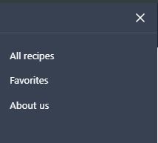

Click on the “Hamburger” bar at the top left corner, and navigate to “Favorites”

Here youll find your favorite meals, if you would like to remove a specific meal,

Kindly just press the “Heart” icon again, it’ll be removed immediately.

**View Full Recipe (Computer and Phone View)**

Kindly click on the following button.



Here you’ll find a detailed instructions.  
You could find the Cooking time at the top, the number of serving, and the rating of the meal.

When scrolling down a little bit, you’ll find the nutritional information of the meal.

Also, youll find the ingredients that are required in order to start preparing the meal.

**If you scroll down a little bit:**

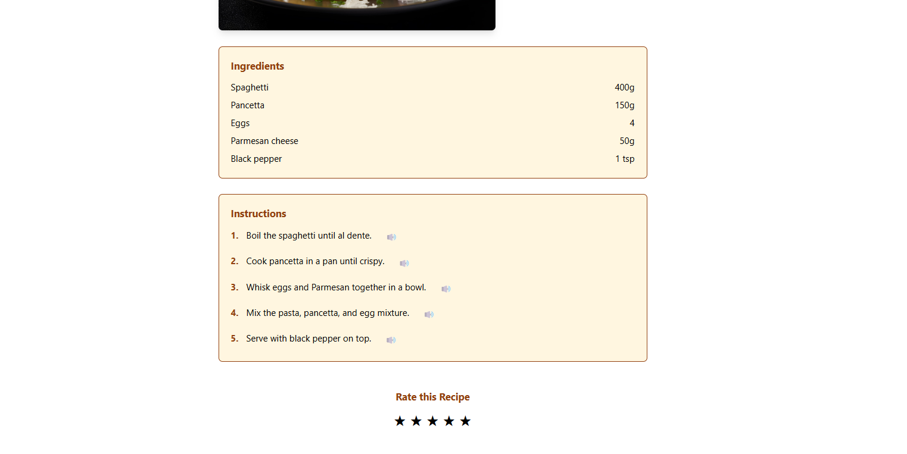



You’ll find the Instructions, with a step-by-step guidance.

If you’re to busy to read the instructions, just press kindly on the “Speaker” Icon to hear a voice command of how the specific step you’re in now.

**About us (Computer and Phone View)**

Here you’ll find the 4 dedicated project members that developed the website, even when they were serving as reserves.